**Analysis**

**Problem**

There are various ways where a climbing experience cannot reach its full potential. Every time I have been climbing I have found that the following have stopped me from for filling my climbing session. Firstly, rock climbing is a strong passion of mine, however I am often restricted with time. Therefore, in the time I have I often don’t achieve the climbs I wanted to.

Secondly, often if one wants to go rock climbing you need at least two people: one to climb and one to belay (belaying is the person who takes in the rope and keeps the climber safe). Often, it can be hard to find someone, that you trust, who can go climbing within the same hours as you.

Lastly, doing rock climbing with a badly fitted harness, horribly made chalk bag and shoes that don’t fit properly ruins a climbing session. So, the gear that you use within climbing is incredibly important.

**Solution**

Routes

Within a climbing centre there are many routes (climbs) and in one session a person can only do so many. So I propose to make a program that allows a climber to plan and prepare for the routes they would like to do.

Partners

A large problem for climbers is that you need two people to be able to climb: the climber and the person to belay. Often a climber will not have a partner to be able to climb with. However, my program will allow a climber to put up their details or their Facebook profile. Having these details available allows a climber to find themselves a partner, giving them an opportunity to climb more! ­­­­

Gear

Within the sport of rock climbing one needs good quality gear. The most important part would be climbing shoes, which have many different styles and prices, thus meaning that there is a very large quantity for a very large community. Within my project I plan to make an option for the user to view climbing gear and possible photos, reviews and links.

**Computational Approach**

Firstly, I believe that my problem is very good for a computational approach as the whole idea is based upon finding climbing centres, and the routes within them. This could be achieved in person with maps and human memory; however, this would be extremely inefficient as one person can only remember so much. Plus, human can make mistakes, for instance remembering where a climbing centre is based incorrectly.

For my partners section a computational approach is something that makes my project so unique. Climbing centres will normally use a non-computational approach, as people will leave their details on a piece of paper for others to contact them with. Yet, with a computational approach it allows people from multiple climbing centres to meet each other. As, people putting their details in one place that any another climber can access, means no limitations to who you can contact and find a climbing partner. It also means that finding a partner could be a click away, rather than having to go out of your way to find a climbing centre that has a collection of contact details for the public. Then once you have found your climbing partner and no longer feel the need for your details, with a computational approach your details can be taken down with one button, compared to having to remember which centres you have put up your details in and removing them in person.

With a computational approach, I can re-use code that I have already written, which proves incredibly helpful in circumstances such as when climbing centres need to be uploaded. Also, it means that it will make this program much smoother and easier, as a computer is able to calculate statistics and process data quickly, accurately and efficiently.

When a person is given long lists of repetitive data it is very likely that at least one error could be made. However, this is not an issue with a computer, as a computer is not distracted and a computer can’t misread data. As well as this, using a computer to create a solution means that I can use abstraction; all the unnecessary information that a person may use would be ignored and only the data that is specific for my solution would implemented. The speed of a computer can be taken advantage for in many way, for my solution it means that people can upload their details/routes and in a very short time it will be visible for everyone. Lastly, a computer is able to run multiple inputs/outputs and execute commands concurrently. This Is essential for my solution, as it means that the program/website could handle a flow of data at once without any loss in speed. For example, if the user was to be midway through uploading a route, whilst it was taking an input of someone uploading their details, the user wouldn’t notice a change. Rather than having to do every task one by one.

**Stakeholders**

Generally younger people are seen at climbing centres from the ages 15-30, as climbing is a very heavy upon the body so it is generally easier for younger people. Yet, it is not only just younger people who climb; there are a fair amount of people from the ages of 30+. So as the range is quite large, the layout for my program must be clear and easy to navigate. Having it clear will mean that everyone who climbs can happily use my program, rather than specify it for the younger ages.

Next, this is aimed more for the people who will climb often, rather than the people who rarely climb and use it as a day out. This is as people who climb often will find this useful as they will want to use their time efficiently and complete the desired climbs within the time they have. However, someone who climbs for a day out will not feel the pressure to use their time efficiently as it will just be fun, rather than for achievement or practise.

I believe that my project will be able to fill the needs of my target audience as it will be very specific yet simple and easy for all to use. Such as the features I will like to add are very specific for people who climb and my solution is what I believe is the best for my stakeholders. As being an avid climber myself I feel that the choices I make will be very helpful and specific for the user. This is as I am a stakeholder myself, so my opinion can be used as a guideline to what my stakeholders will enjoy. Yet, I can’t only rely on my opinion, so as I create my program I can use prototypes with my stakeholders to see if it is something that they’d happily use, and see any likes/dislikes to make my project even more specific for the users.

**Research and Similar Projects**

There are many similar projects to what I would like to achieve, mostly being done via a website. Many being very heavily forum and article based. Such as asking others online for recommended for good gear, reviews, and opinions on climbing centres. Also there are many articles about what are the ‘best’ climbing shoes, rucksacks, harnesses etc. Furthermore, there are a lot of articles about famous climbers and what they have done recently. Therefore, presenting that the rock climbing community like to be connected and be able to have the opportunity to ask, answer and to look over what others have to say. A good example of this is: [www.ukclimbing.com](http://www.ukclimbing.com).

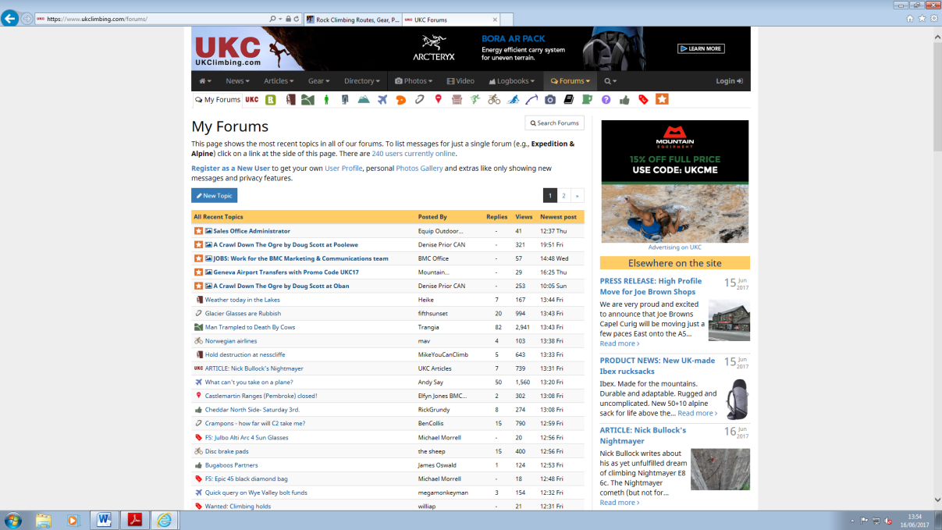

There are many projects similar to what I’d like to develop; the closest two is:

* A Website: **www.rockclimbing.com**. This website is quite similar to most climbing websites, however has some features that I like a lot, and that are very similar to what I plan to add.
* An App: **E10Climbing**. The app is quite old, however has a lot of features that I will like to be able to have within my project. Also, it is quite different to most climbing projects, as it is heavily based upon the Routes aspect.

1. **www.rockclimbing.com**

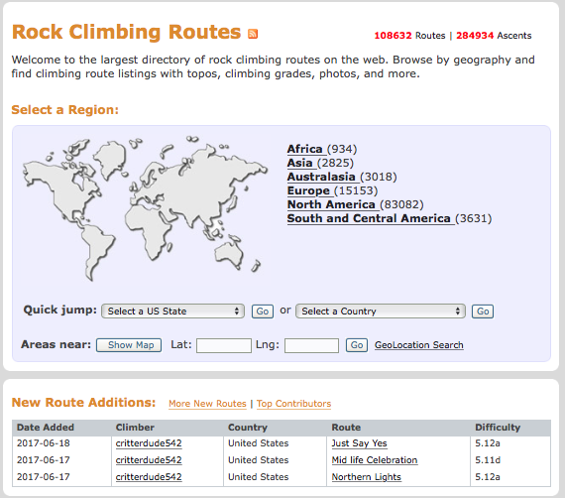This website has lots of features such as: Forums, Routes, Gear, Photos and Videos. I feel that this website is a very great project, which contains lots of similar ideas to what I believe my project will come out to. One very large part about this website that it has a ‘Routes’ section, an option I would like to implement into my program. As this website has obviously quite a lot of traffic, it has been made to include climbing routes all over the world. Allowing user to plan trips to other countries/regions and do specific climbs that they are interested in. It even has a small log area to present to the user the most recent uploads, showing how even now people are still uploading routes. Showing a log of recent uploads will ensure the user that the routes shown are often recent and up to date.

Once you have narrowed down your search to your area, it splits into two different sections: Climbing Areas and Indoor Gyms. I think that having both is a very nice idea, as it will add more variation to the project, and then possibly draw in more people to use my project. As well as this, once the user has chosen their specific climbing area/indoor gym it gives: directions, near towns, quantity of climbs and more. Having details about the climbing area/gym is a very nice idea as it gives users confidence to go to new places, visit new routes and try them out.

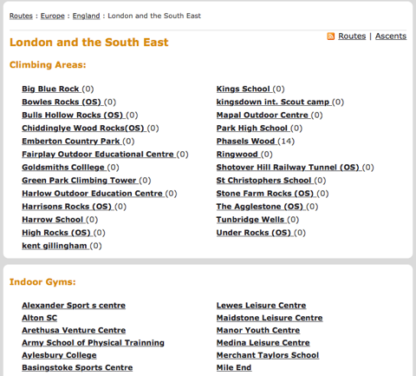

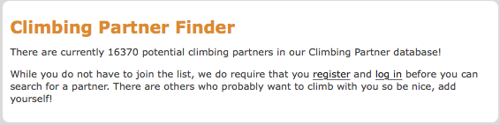Lastly, they have a ‘Partners’ option, by signing up it allows you to meet lots of other climbers that wish to meet a new climbing partner. Upon clicking the ‘Partner’ option it tells you the number of people who have signed up for this option, doing this will also re-insure the user that they are highly likely to find a new climbing partner and therefore use the website more often.

1. **E10Climing**

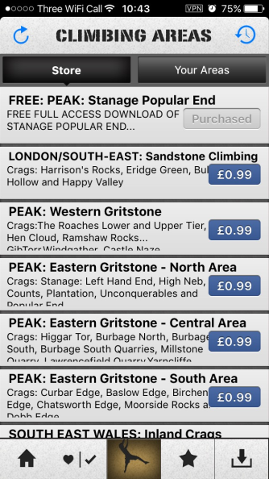This is an app that is available for both Android and iPhone. Yet being an old app it is still very well-functioning and the Routes feature is very nicely done. This App allows the user to browse through a large collection of routes and buy and download them on their device. However, even with the good functionality of this App, I have two large dislikes. The first dislike is the layout, I think it isn’t very nice to look at and use that doesn’t make it a fun app to use/navigate. Secondly, you must pay money for all but one of the ‘climbing areas’, which I feel is very off-putting for a user.

Once you have downloaded your ‘climbing area’ you can browse through the numerous routes that they have added. Each collection of routes on a rock-face is split into sub categories with varying number of routes, averaging around 9 routes per rock face. Each route that you click on can have a rate and a description, which is a very nice feature for a user to plan their day.

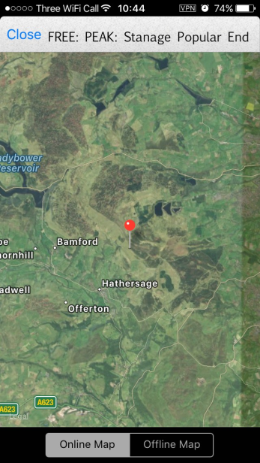

One feature I like a lot about the ‘climbing area’ is that you have an option to see it on an interactive map, which you can zoom in and out and scroll across the country. The reason I like this map is that it isn’t just static, such as a photo or directions, it allows the user to easily navigate and find the ‘climbing area’.

­­­­­­­­­­­

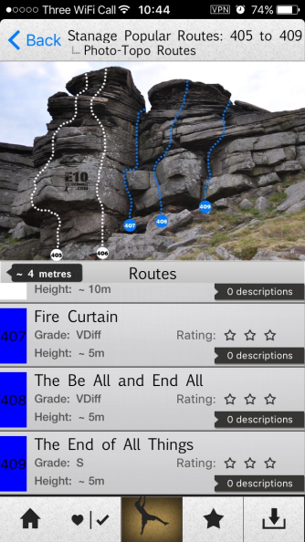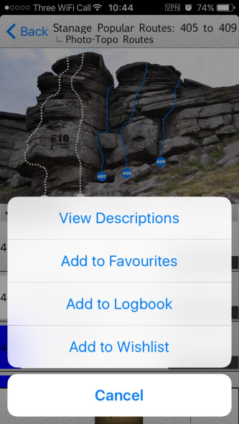

Another feature I like a lot is that upon the picture of the rock face it shows coloured lines mapping the route, which is very aesthetically pleasing. As well as that mapping each route lets the user find the specific route they would like to do. Once the user has found the route that they like they are able to add it to a ‘Wishlist’, which is a different section. Having this option allows the user to plan their day and spend time on each of their climbs.

**Survey**

For my survey I asked people I know who climb and random people from a climbing centre. I asked three questions, and each time there was a clear majority presenting what the public would like most.

My first question was which would be their preferred platform for my project. My three options were: App (for IPhone), a website and a program. From the graph it is obvious that the favoured platform would be an App. Comments afterwards stated how it would be best for on the move and can one can use it anywhere.

My second question was whether they had ever used a program/app/website for climbing in the past. From the graph we can see how it is a dominant No, however a few had said they had used something in the past. This shows to me that I must be very different and bring something new to the table to be able to draw more people in to use it.

The final question I asked was what part of my project they liked the idea of the most. A large majority favoured the feature about the routes. I believe that this corrilates with my last question as it is sometyhing new and different that people have not seen previously with other projects. Therefore this shows to me that I should spend a significant amount of my time making this section of my project very unique and easy to use, and most of all: useful. As well as this no one went for the gear section, I think this because there are so many projects that souly focus on that, which are very well made, that a new prokect not souly focussed on it wouldn’t be a heavily used.

**User Requirements**

In Conclusion, I have found that there are many projects similar to mine which are mainly based online and have many forums and articles. Also by researching [www.rockclimbing.com](http://www.rockclimbing.com) and E10Climbing I have found nice features that I would like to include into my project. Plus, I have found many repetitive features that I would like to ignore. First of these are the very static and boring layouts, which is very off-putting.

From my survey, I can gather some very important points. Firstly, it has shown to me that the majority of people would like to be able use this project on their phone, as it can be used anywhere anytime. Also, not many people have used a website/app for climbing, so I must focus a lot of my time on my Routes section. This is as it is new and different, as it is clear that the other projects haven’t been heavily used. Lastly, from my survey it clearly shows that no one would like for a gear route to be added. Therefore, I shall remove that from my design and focus more time on my partners and routes section.

**Specific User Requirements**

|  |  |  |
| --- | --- | --- |
| **Requirement** | **Description** | **Justification** |
| Wishlist | As seen from studying other projects I have encountered a ‘Wishlist’ section, it is a list of routes that the user can add/remove. | This would be needed as it means the users will be able to quickly look at what they had previously seen and wanted to climb, instead of trying to find it again. |
| Map Support | Having map support will allow the user to find the specific point of the climbing area/gym. | A map would be the best as it is very easy to use for all and will make finding climbing centres that much easier, meaning my app will be nicer to use. |
| Recent Route Upload | This will allow the user to see a list of the most recent uploads that others have put up. | This isn’t as necessary as others however it allows the user to be able to quickly view a specific route. Proving especially good if they have been waiting for a specific route. |
| Details of Climbing Area/Gym | Presenting details to the user will allow them to be able to learn about the area before they visit, such as where it is/how many routes/places nearby. | Presenting details to the user will allow them to be able to learn about the area before they visit, such as where it is/how many routes/places nearby |
| Number of Partners | Before one becomes uploads their details they will be able to see how many others have uploaded their details. | Achieving this will mean the user could be given that push to upload their details if they were in doubt. |
| App Platform | my project will be on the app platform, so users with an IPhone will be able to use my app | This was the most wanted platform by the stakeholders therefore it is what I shall use, to be as specific to my audience as possible. Also, as my target audience has a large amount of young people – an app would be very ideal and could draw them in to use it. |

**Features**

Essential features of my project via a computational solution are:

* A Clear Homepage – As said earlier my project must be very clear and accessible for all people, from all ages. Therefore, my home page must be very easy for all to navigate and use. These are essential as this project should be fast and easy to use. Plus, it should be something someone is happy to use with ease, instead of it being easy for some but harder for others e.g. the older ages. As well as this, each option will be totally separate and must be accessed via the homepage. Achieving this will mean that it is a clear way for a user to be able to get to their desired option, back to the homepage and then smoothly to their next desired option.
* Home Button – As I will have multiple options of navigation I feel it is essential that there will be a home button that is always in the same place on each part of my project (obviously excluding the homepage its self). This is a total necessity as earlier said my stakeholders aren’t a very specific group, so this project must be easy for all ages. Therefore, an obvious home button in the same place will allow fast and smooth navigation without any confusion.
* Repetitive Structure – For the user to upload routes, every upload should look the same before any data has been entered. Therefore, it will feel very familiar for users to upload, due to no change of layout. Once again allowing people of all ages to easily use this project without a struggle.
* Database – This is vital as the data about the routes, climbing centres, partner details. Without this the project will be rendered useless as it needs to be able to store everyone’s inputs to view all the inputs from multiple users.
* ‘Contact Me’­­­­­­­­­­ - To have this would allow the users to be able report any bugs that hadn’t been found in earlier testing. As well as this it could allow users to ask any questions, if they were confused at all.

**Hardware/Software**

Due to the results and the majority of the answers from my survey I have decided that I will be making my project on an App platform. Therefore for hardware requirements there will not be much, as it will not be very large or need a lot of power to use. As it’ll be quite small all the user will need is an IPhone, containing the latest IOS. As well as this the device must have GPS support and access to Wi-Fi/3G/4G.

**Limitations**

My project has a lot of options and many parts that can be added or removed, however for my ideal solution my limitations would be:

* User Connection – Creating a platform for users to be able to connect along with all the other features of my project may prove difficult. As lots of time will be spent working on this, therefore to be able to have my other features I may have to limit the extent I would go to have this fully working within my ideal project.
* Layout – As my project may unravel to be much more complex than I had originally thought I will not be able to create the best looking project. This is as I feel the priority is within the structure of the code, rather than the overall aesthetics
* Complexity of the ‘Gear’ Option – Rock climbing gear is very extensive and has lots of different looks, uses and reviews my ‘Gear’ option within my project have to be limited. Also due to the reasons listed I feel reviews will be better if they are drawn from an external source, yet this may not be possible due to how vast it all is.
* App/Website – Creating a fully functioning app or website will take a lot of time, meaning that I will have less time to work on the actual function of the App/Website. Therefore, I may have to turn to creating a program for the computer instead. Yet having as just a program on the computer is not the desired outcome as I feel an App or website would be the best platform for my project due to it being a lot more accessible.
* Controlling Data – In indoor gyms climbing routes are removed and new routes are setup very often. Therefore, for the ideal project the no longer existent routes will be removed. However, to achieve this will be very difficult as I as the creator may have to have a timer, which will remove routes after a certain amount of time. Or possibly create a ‘Delete’ option for the users, yet this could further lead to more area for error. As users may delete routes that are still in use, or users may never remove any at all.
* Cross Platform – One large limitation is that being able to have my project available for all platforms. As being able for it to be available for both Apple and Android devices would be the desired outcome. However I don’t think it will be possible for this to happen, as I am going to be coding in X-code which is very easy to create for Apple devices.

**Project Management Methodologies**

The method I shall choose is: Rapid Application Development (RAD) first involves gathering all the requirements for the project. Then one must make lots of prototypes early on, then having these prototypes tested repetitively. One large feature is the re-use of software components. As well as this one must follow a specific schedule of coding and testing. Lastly it is the least formal in terms of communication.

This method is the best for what I want to do for multiple reasons. The first of which is that you must follow a timetable of coding and testing. This is perfect for me, as I am working alone I must be able to do both coding and testing. So, to structure when I am to do what is best for the efficient of creating this program, as well as that it is very good for evenly distributing my time. Plus, as for what I have to do I don’t have masses of time, efficient working is an absolute necessity. Next, I believe the use of prototypes are vital, as you will have the base structure for what you will want to do. Thus, once that has been made and tested I will be able to easily build onto it and make it more complex. Lastly, I will be constantly re-using software; therefore this management methodology is brilliant for the way I want to create this project.

A commonly used methodology is the waterfall methodology. This is the idea that you plan all of your code and testing out. Once this has been completed, the creator will code the entire project at once, without testing. Then once it has been completed, all of the testing will carried out at once. So the coding and testing are totally separate. This is generally better for single users, however I think this is a very bad route of creating my project. This is as being able to build upon working prototypes and test them one at a time means that it testing will be very easy as the complexity will be slowly built up. But with the waterfall methodology there it will be very hard to detect any logical errors, as there will be so much code to check. As well as this, logical errors aren’t presented by an IDE so within multiple lines of code it will be very hard to find. Furthermore, once the code is very complex changing one part of the code could possibly have a domino effect and effect even more code causing more error. As pointing out many errors within this mythology it presents why RAD is a very good methodology for my project.

**Success Criteria**

The following are criteria for that if feel I must fulfil:

|  |  |
| --- | --- |
| **Criteria** | **Justification** |
| For users to able to find uploaded routes to be able to see: a photo and a grade. This will be achieved by either the user uploading or me, the admin, uploading. | This is the bare minimum that I would like to achieve within my Routes section, as it will allow them access the uploaded routes. |
| The data of the routes will be saved, into a database, until removed. | Without the data to be saved, anything uploaded will just be lost; rendering my solution useless. |
| Users shall be able to upload details about themselves and be able find others to climb with. | For my Partners section this is the contents I expect would be easily achievable. |
| The layout must be very clear and easy for all to use, so people of older ages can use without struggle. | As earlier stated, my target audience has a very large range in terms of age. So, my solution must be very easy to navigate for all. |
| Must be a reliable solution, establishing this via lots of thorough testing. | I believe that if my solution isn’t reliable, it has a lot of features then it isn’t a good solution. It should be basically without error and one should be able to use it without the worry that it will crash/encounter an error. |